2.cafe

## 1.truffels-Phone number

**080 49652818**

**Cuisines**

[American](https://www.zomato.com/bangalore/restaurants/american), [Burger](https://www.zomato.com/bangalore/restaurants/burger), [Cafe](https://www.zomato.com/bangalore/restaurants/cafes)

**Cost**

AVERAGE

₹800 for two people (approx.)

VAT extra

Cash and Cards accepted

**Opening hours**

|  |  |
| --- | --- |
| Mon | 12 Noon to 10:30 PM |
| Tue | 12 Noon to 10:30 PM |
| Wed | 12 Noon to 10:30 PM |
| Thu | 12 Noon to 10:30 PM |
| **Fri** | **12 Noon to 10:30 PM** |
| Sat | 12 Noon to 10:30 PM |
| Sun | 12 Noon to 10:30 PM |
| Address 28, 4th 'B' Cross, Koramangala 5th Block, Bangalore  [See 4 more locations ›](https://www.zomato.com/bangalore/restaurants/truffles) Highlights Home Delivery  Table booking not available Featured in Collections [Kickass burgers](https://www.zomato.com/bangalore/best-burger?ref=rescoll) [Great cafes](https://www.zomato.com/bangalore/top-cafes?ref=rescoll) [Sweet tooth](https://www.zomato.com/bangalore/dessert-places?ref=rescoll) Known For Their wide variety of burgers | Image result for truffles koramangala |

## 2.onesta-Phone number

**080 49653087**

Table booking recommended

**Cuisines**

[Pizza](https://www.zomato.com/bangalore/restaurants/pizza), [Cafe](https://www.zomato.com/bangalore/restaurants/cafes), [Italian](https://www.zomato.com/bangalore/restaurants/italian)

**Cost**

AVERAGE

₹600 for two people (approx.)

Cash and Cards accepted

**Opening hours**

|  |  |
| --- | --- |
| Mon | 12:30 PM to 11 PM |
| Tue | 12:30 PM to 11 PM |
| Wed | 12:30 PM to 11 PM |
| Thu | 12:30 PM to 11 PM |
| **Fri** | **12:30 PM to 11 PM** |
| Sat | 12:30 PM to 11 PM |
| Sun | 12:30 PM to 11 PM |

**Address**

501, Binnamangala Extension, 1st stage, C.M.H Road, Indiranagar, Bangalore

## C:\Users\User\Desktop\download.jpgHighlights

Valet Parking Available

Unlimited pizzas and desserts

Rooftop

### Featured in Collection

[European & Mediterranean](https://www.zomato.com/bangalore/continental-restaurants?ref=rescoll)

## 3.Indian Paratha Company-Phone Numbers

**+91 9886699409**  
**+91 9902009977**

**Cuisines**

[North Indian](https://www.zomato.com/bangalore/restaurants/north-indian), [Cafe](https://www.zomato.com/bangalore/restaurants/cafes)

**Cost**

AVERAGE

₹500 for two people (approx.)

Cash and Debit Cards accepted  
Wallet accepted

**Opening hours**

|  |  |
| --- | --- |
| Mon | 7 AM to 11 PM |
| Tue | 7 AM to 11 PM |
| Wed | 7 AM to 11 PM |
| Thu | 7 AM to 11 PM |
| **Fri** | **7 AM to 11 PM** |
| Sat | 7 AM to 11 PM |
| Sun | 7 AM to 11 PM |

**Address**

1/2, Guttahalli, Kasaba Hobli, Devanahalli, International Airport, Bangalore

## C:\Users\User\Desktop\home.jpgHighlights

Breakfast

Home Delivery

Wheelchair Accessible

Vegetarian Only

Outdoor Seating

Smoking Area

### Featured in Collections

[Flavours of Punjab](https://www.zomato.com/bangalore/punjabi-restaurants?ref=rescoll)  
[Veggie friendly](https://www.zomato.com/bangalore/vegetarian-restaurants?ref=rescoll)

## 4.Euki-

## Phone number

**080 45128714**

Table booking recommended

**Cuisines**

[Italian](https://www.zomato.com/bangalore/restaurants/italian), [Mexican](https://www.zomato.com/bangalore/restaurants/mexican)

**Cost**

AVERAGE

₹900 for two people (approx.)

VAT & service charges extra

Cash and Cards accepted

**Opening hours**

|  |  |
| --- | --- |
| Mon | 12 Noon to 11 PM |
| Tue | 12 Noon to 11 PM |
| Wed | 12 Noon to 11 PM |
| Thu | 12 Noon to 11 PM |
| **Fri** | **12 Noon to 11 PM** |
| Sat | 12 Noon to 11 PM |
| Sun | 12 Noon to 11 PM |

**Address**

1557, Divya Towers, 11th Main Road, 4th T Block, Jayanagar, Bangalore

## Highlights

Vegetarian Only

Wifi

Serves Jain Food

Live Sports Screening

### Featured in Collection

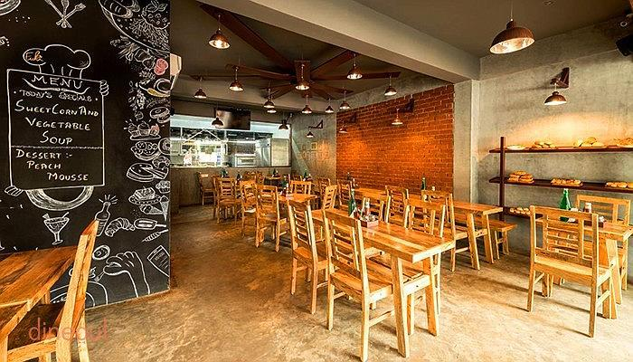[Veggie friendly](https://www.zomato.com/bangalore/vegetarian-restaurants?ref=rescoll)